Economic Models

A model is simply a framework that is designed to show complex economic processes.

Economic Models
In economics, a model is defined as a theoretical construct that represents economic processes through a set of variables and a set of logical or quantitative relationships between the two. A model is simply a framework that is designed to show complex economic processes. Most models use mathematical techniques in order to investigate, theorize, and fit theories into economic situations.

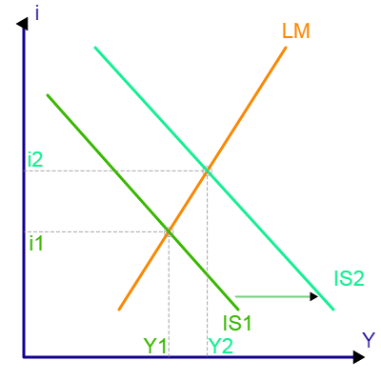
Uses of an Economic Model
Economists use models in order to study and portray situations. The focus of a model is to gain a better understanding of how things work, to observe patterns, and to predict the results of stimuli . Models are based on theory and follow the rules of deductive logic.
Economic model diagram
In economics, models are used in order to study and portray situations and gain a better understand of how things work.
Economic models have two functions:
1) to simplify and abstract from observed data, and 2) to serve as a means of selection of data based on a paradigm of econometric study. Economic processes are known to be enormously complex, so simplification to gain a clearer understanding is critical. Selecting the correct data is also very important because the nature of the model will determine what economic facts are studied and how they will be compiled.
Examples of the uses of economic models include: professional academic interest, forecasting economic activity, proposing economic policy, presenting reasoned arguments to politically justify economic policy, as well as economic planning and allocation.

Constructing a Model
The construction and use of a model will vary according to the specific situation. However, creating a model does have two basic steps: 1) generate the model, and 2) checking the model for accuracy - also known as diagnostics. The diagnostic step is important because a model is only useful if the data and analysis is accurate.

Limitations of a Model
Due to the complexity of economic models, there are obviously limitations that come into account. First, all of the data provided must be complete and accurate in order for the analysis to be successful. Also, once the data is entered, it must be analyzed correctly. In most cases, economic models use mathematical or quantitative analysis. Within this realm of observation, accuracy is very important. During the construction of a model, the information will be checked and updated as needed to ensure accuracy. Some economic models also use qualitative analysis. However, this kind of analysis is known for lacking precision. Furthermore, models are fundamentally only as good as their founding assumptions.
The use of economic models is important in order to further study and understand economic processes. Steps must be taken throughout the construction of the model to ensure that the data provided and analyzed is correct.

KEY POINTS
- Many models use mathematical techniques in order to investigate, theorize, and fit theories into economic situations.
- Economic models have two functions: 1) to simplify and abstract from observed data, and 2) to serve as a means of selection of data based on a paradigm of econometric study.
- Creating a model has two basic steps: 1) generate the model, and 2) checking the model for accuracy - also known as diagnostics.
- Examples of the uses of economic models include: professional academic interest, forecasting economic activity, proposing economic policy, presenting reasoned arguments to politically justify economic policy, as well as economic planning and allocation.

Source: Boundless. “Economic Models.” Boundless Economics. Boundless, 03 Jul. 2014. Retrieved 15 Apr. 2015 from https://www.boundless.com/economics/textbooks/boundless-economics-textbook/principles-of-economics-1/economic-models-43/economic-models-160-12258/

Questions:

- What is a model?
- Why do models use mathematical techniques?
- How do economists use models?
- What two functions do models serve?
- What are some examples of economic models?
- What is checking accuracy called?
- Why must you check for model accuracy?
- What are the limitations of models? Explain.
- Why are economic models important?
- How will you use economic models in your studies this semester?

