The Use of Graphs in Economics
Economic theory identifies important economic variables and attempts to explain their relationships. Economists frequently rely on graphs to illustrate these relationships.

Let’s take a simple example of the relationship between the amount of oil a household uses and how much it costs. During a particular period of time—say, a month—a household can use different amounts of oil. Depending upon how much oil is used, the cost to the household will vary. Let’s say oil (for heating and hot water) costs $1 per gallon. Table 1 gives information on the costs of using different amounts of oil.
Point on Graph | Amount of Oil Used (Gallons per Month) | Cost ($)
origin | 0 | 0
a | 20 | 20
b | 40 | 40
c | 60 | 60
d | 80 | 80
e | 100 | 100
Figure 2
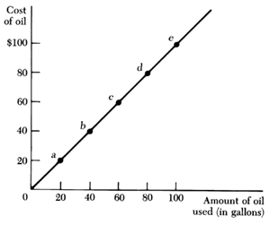
We can illustrate this same information on a graph. In Figure 2 we measure increasing amounts of oil as we move out from the origin on the horizontal axis, and increasing costs of oil as we move up from the origin on the vertical axis.

(Generally, the independent variable is placed on the horizontal, or x, axis, and the dependent variable is put on the vertical, or y, axis. Here, the amount of oil is the independent variable, and the cost is the dependent variable. The cost depends on the amount of oil used, given price.)
Each combination of oil and its cost is represented by a point on the graph. When we connect all the different points, we have a graphical representation of the relationship between different amounts of oil used and the respective costs.
The graph provides a picture of the relationship between the amount of oil used and the cost to the household. It tells us that the cost goes up as the household uses more oil per month. It represents exactly the same information contained in the table, but the graph presents the relationship in summary form. It is an efficient way to express the relationship between these two variables. Most people can more readily understand a visual comparison of relative size than they can see relationships in a table of numbers. Such illustrations are useful in developing economic theory about the more complicated relationships among economic variables.
The relationship between variables may be positive or negative. In Figure 2, the graph shows a positive relationship between oil used and cost—as oil use increases, so does cost. If there is a positive relationship between two variables, the graph will slope upward to the right. If there is a negative relationship between two variables—as one increases, the other decreases—the graph will have a negative slope (downward to the right). For example, if a household uses wood as well as oil for heat, its use of oil will decrease as its use of wood increases. We can represent this relationship in a table and in a graph (Table 2 and Figure 3).
Wood (in Cords) Oil (in Gallons)  0 60  1/4 50  1/2 40  3/4 30  1 20 | Figure 3
The slope of a graph tells us precisely how one variable changes with another. The slope is the change in the dependent variable divided by the change in the independent variable between two points. (Other ways to say this are the height over the base of the line, or the rise over the run.) For example, the slope of the graph in Figure 2 equals the ratio of the change in the cost over the change in the amount of oil used. In moving along the line from point b to point c, the change in cost equals $20, and the change in the amount of oil used is 20 gallons:

slope | = | change in cost  change in oil used | = | $20  20 gal. | = | 1
(Often the symbol D is used to denote the change in a variable.) In this case, the slope is equal to 1. (What is the slope of the graph in Figure 3?)
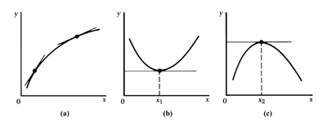
Graphs of the relationships between economic variables can also be curved lines, as in panels (a), (b), and (c) of Figure 4. In these cases, the slope changes as we move along each line. (The slope can be approximated by drawing a line tangent to each point on the curve.) For example, in Figure 4(a), the positive slope of the line becomes less steep as we move to the right. In Figure 4(b)from 0 to x₁, the slope is negative (y decreases as x increases); beyond x₁, the slope of the line is positive. At x₁, the slope of the line is 0, and y is at its minimum value. In Figure 4(c) the slope is positive to x₂ and negative beyond x₂. At x₂, the slope of the graph is 0, and y is at its maximum value.

